Sohal Patel

Week 6 (Database Design Concepts & DB Warehouse)

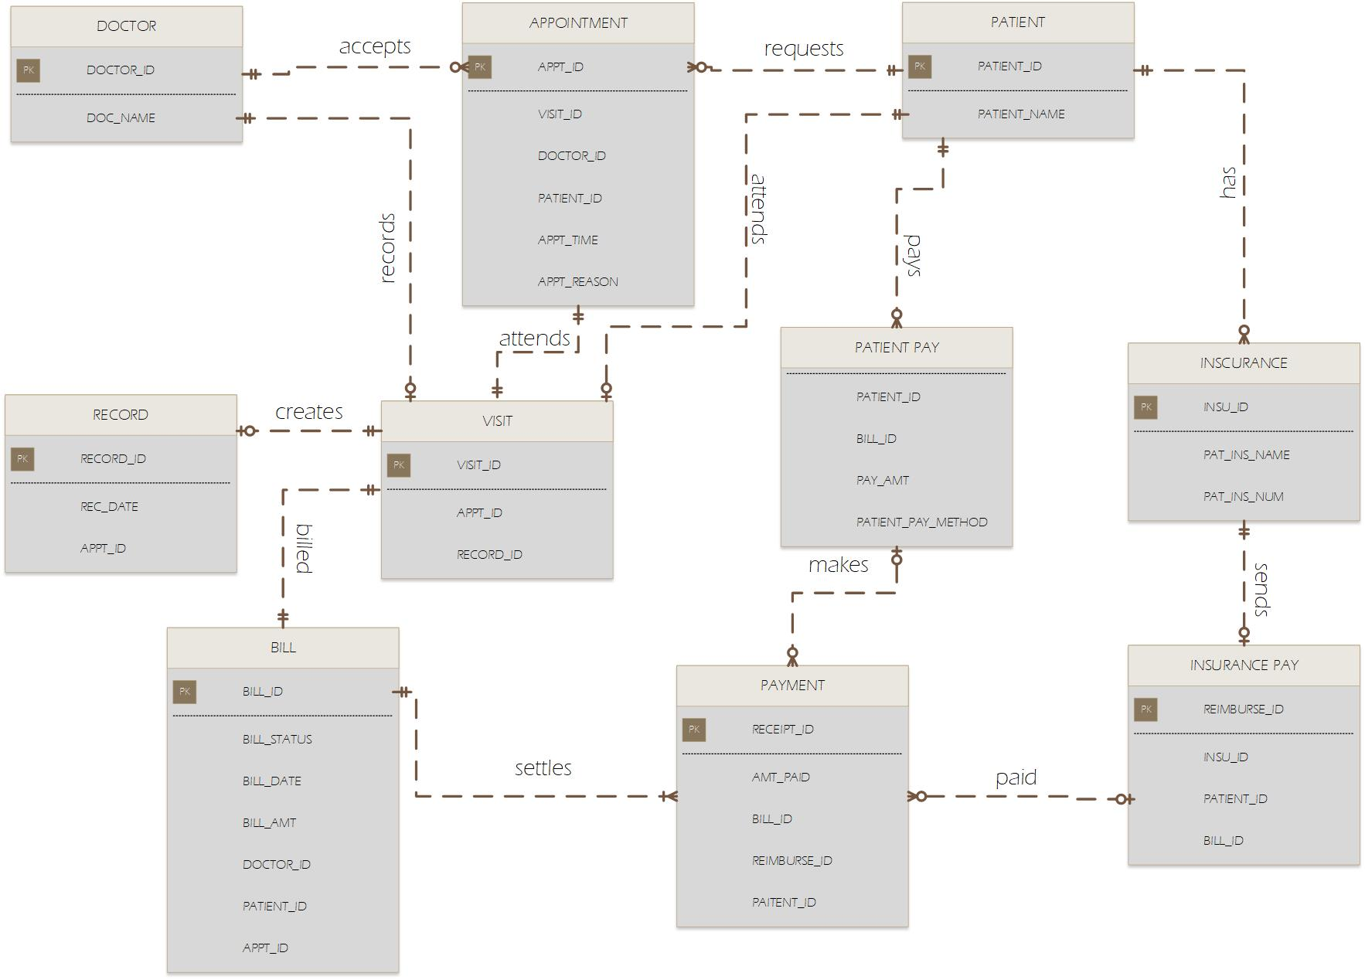8. The attributes with the Private keys are not necessary but just to show how it connects if it had attributes.

Lessons on Autonomous Data warehouse Design

The video provides a snippet preview on design, implementation, and functions of Oracle Autonomous Data Warehouse. It is important to note that the Autonomous Data Warehouse offers an easy-to-use, entirely independent database, which scales elastically, deliver fast query performance, and needs no database administration. Once created, an Autonomous Data Warehouse database can be easily deployed in either serverless or dedicated infrastructure platforms. Serverless infrastructure platform presents a simple and elastic deployment option while dedicated infrastructure platform serves as the private cloud operating in public cloud deployment platform. Therefore, one can conclude that the Autonomous Data Warehouse is easy-to-use since it is about loading the data and running, the Exadata technology makes it fast, and it scales elastically with no downtime.

Opening the Autonomous Data Warehouse calls for four simple steps namely creating the database name, allocating the number of CPUs, allocating the number of terabytes, and providing the administrator password. The database usually opens and becomes ready for connections once the four steps are realized. Autonomous database imply that all the features of the database are automatically implemented. One of the most important features of the Autonomous Data Warehouse is its automated management system which offers end-to-end management of data warehouse. This implies that the database has the capacity to provide new database instances, grow, shrink and compute storage, patch, upgrade, backup, and restore the database. In addition, the service console feature helps in managing the full lifecycle of the database.

The Autonomous Data Warehouse provides automated tuning which offers load and go feature. This feature provides fast performance, web-based monitoring console, and in-built resource management platforms. The database is reliable since it is made up of fault-tolerant and highly available Exadata infrastructure with automatic backups and online patches. Lastly, the autonomous data warehouse is about instant elasticity. This implies that the user pays for exactly what they use. Thus, the size of the data warehouse to the exact number of CPUs and terabytes required is not constrained by fixed building blocks. The architecture of the autonomous data warehouse comprises of developer tools, data integration services, and business intelligence services. The data aggregation technique can be used to upload data while the business analytics solution is used to access the data. The Oracle Autonomous Data Warehouse Cloud supports the existing tools running in Oracle Cloud and Oracle Cloud Services such as Oracle Analytics Cloud.